Tutorial 4 – Tasks

Payable Contract Methods
- In addition to paying the network to mine your transaction, a payable contract method also receives some SETH as payment to the contract for the operation.
- This is an ideal use case for implementing a feature that would pay for a Ticket as with our project brief.
- Using the code example “payableContract”, deploy to Sepolia using Remix.
- “payableContract” is an ERC20, just like in the previous tutorial, with an additional contract method that allows you to buy a token from the contract
- Once deployed, amend the “sendPayableTransaction” project to buy a token from your new contract.
- Confirm:
  - The movement of SETH from the senders account to the contract address by checking the transaction on etherscan
  - The movement of SETH from the senders account to the contract address by checking the transaction on the “checkBalance” project.
  - Confirm the movement of a token from the contract to your token balance and away from the contract’s token balance.

ERROR INSUFFICIENT BALANCE!
When you create the contract, the token supply is allocated to the wallet executing the create contract transaction.
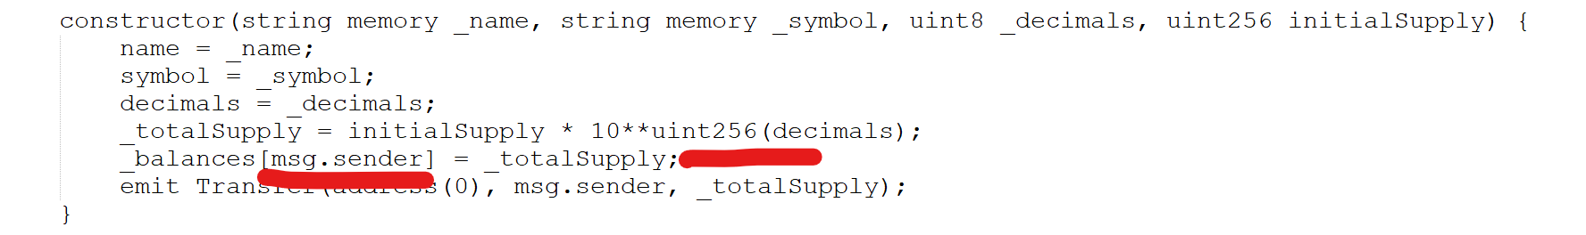
When you buy a token it is assuming that the tokens are being allocated from the address of the contract:
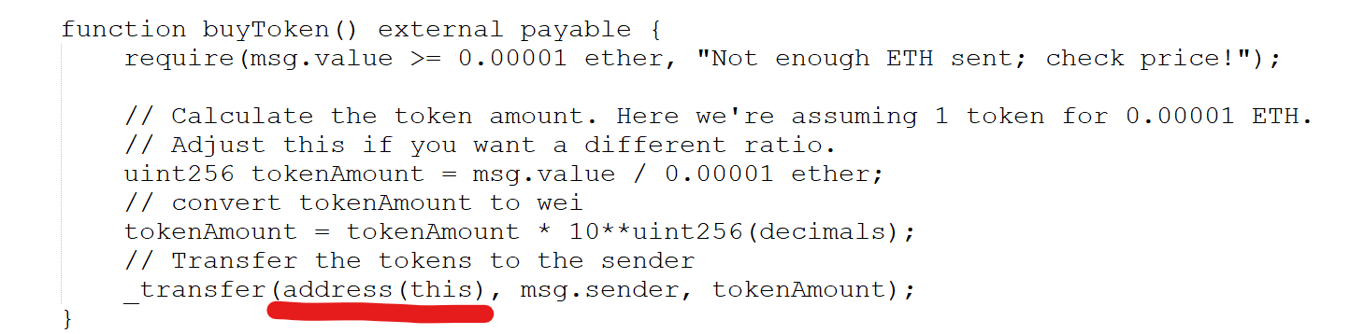
So don’t forget to do one of the following to avoid an error:
- Transfer some tokens to the contract address
- Change the code so that it takes from the supply of the contract creator.

