Tutorial 3 – Tasks

ERC-20
- ERC-20 is a blockchain standard for implementing tokenised assets on a blockchain in a smart contract.
- Check the “tokenContract” example from the repository. This contract implements the ERC20 interface.
- Use your skills from Tutorial 2 to:
  - Deploy an instance of tokenContract to Sepolia
  - Return to the “checkBalance” code sample to see your Token balance.
  - Remember a whole token is 10^18 wei. E.g. 1 Token == 1000000000000000000 wei.
  - Transfer a token to another wallet using Metamask
    - To do this you will need to go to the “Tokens” section of Maskmask and add you token to the list using the contract address of the ERC20 token you deployed.
    - Execute the send on Metamask
    - Return to your Web3 code to check the token balance of the recipient.
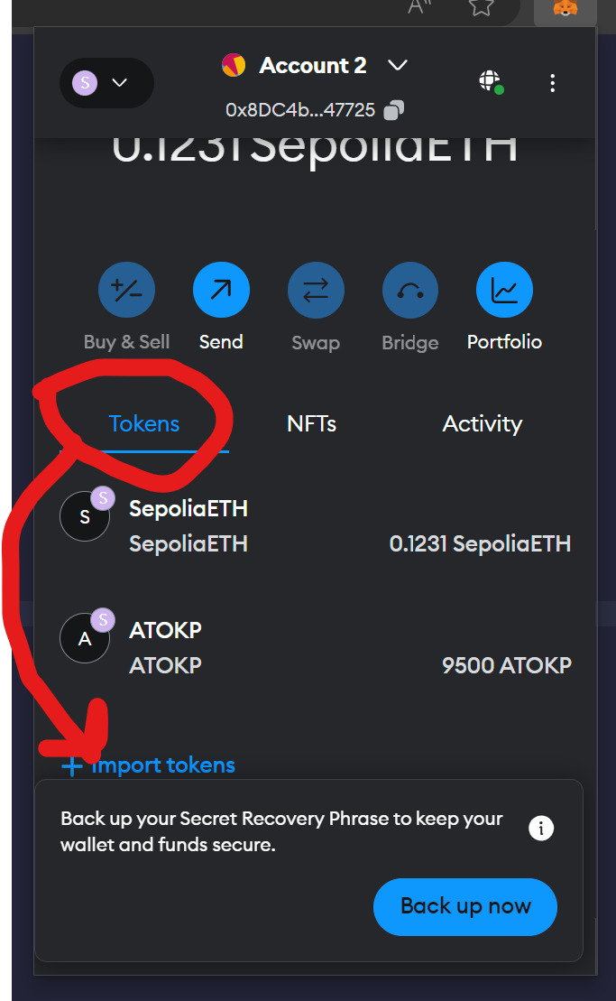
- Write web3 code to execute “transfer” on the ERC20 contract you deployed
- View the transfer transaction on etherscan
- Confirm the new balance on the “checkBalance” web3 example after the transaction mines.

