Tutorial 1 - Tasks

Create a Wallet with Metamask
- Install MetaMask in your browser
- Connect your MetaMask instance to the Sepolia Test Network
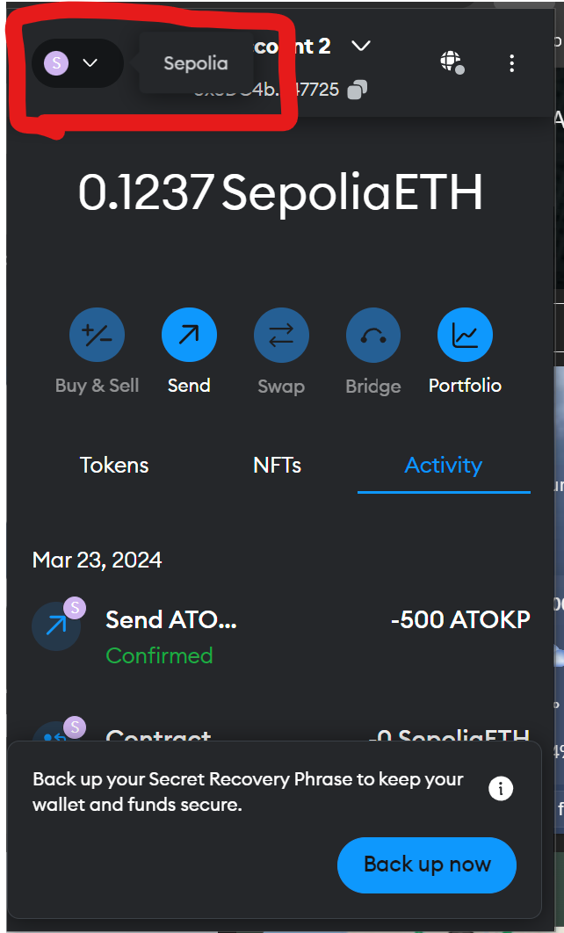

- Use one of the many Sepolia faucets to add Sepolias native crypto currency (SETH) to your new account. For example, Sepolia PoW Faucet (pk910.de)
- Use Sepolia’s block explorer to view the transaction that added SETH to your account.
- Use MetaMask to send a small fraction of your balance to one of the other class members.
  - Find the transaction on the block explorer that executed the transfer of SETH

Create a Wallet with Web3
- Clone the Module’s Web3 examples from https://github.com/andylegear/web3examples.git
- Use the code example “createWallet” to make a wallet with Web3.
- Top up the account similar to the previous example.
- Use the Import feature on Metamask to to add your account and view it’s balance.
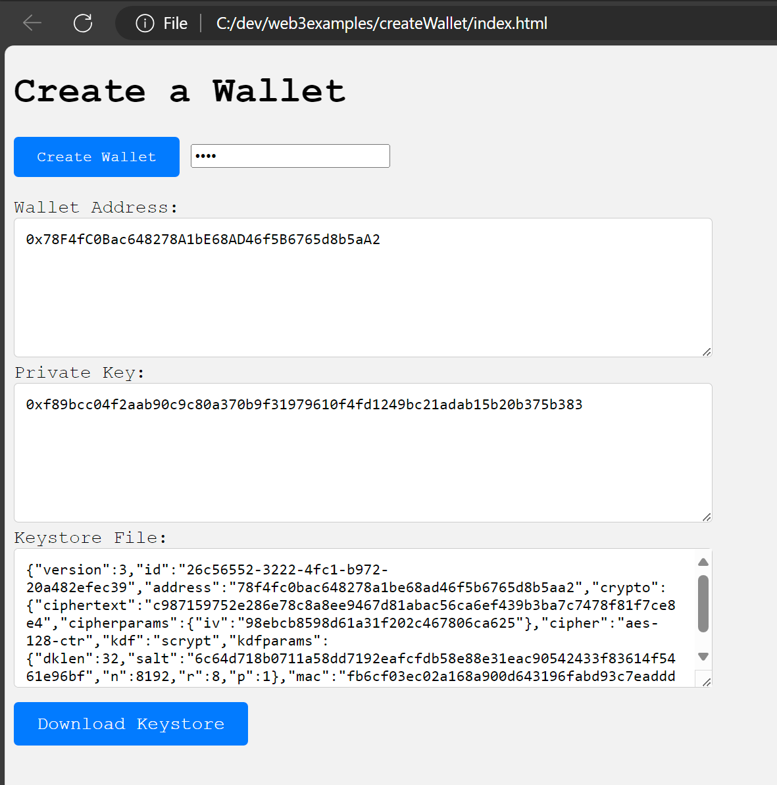

Check Your Balance Using Web3
- Use the code example “checkBalance” to query your accounts’ balances using Web3.
- For now we will just check the SET balance. We will return to this example in a later tutorial to check “Token” balances.
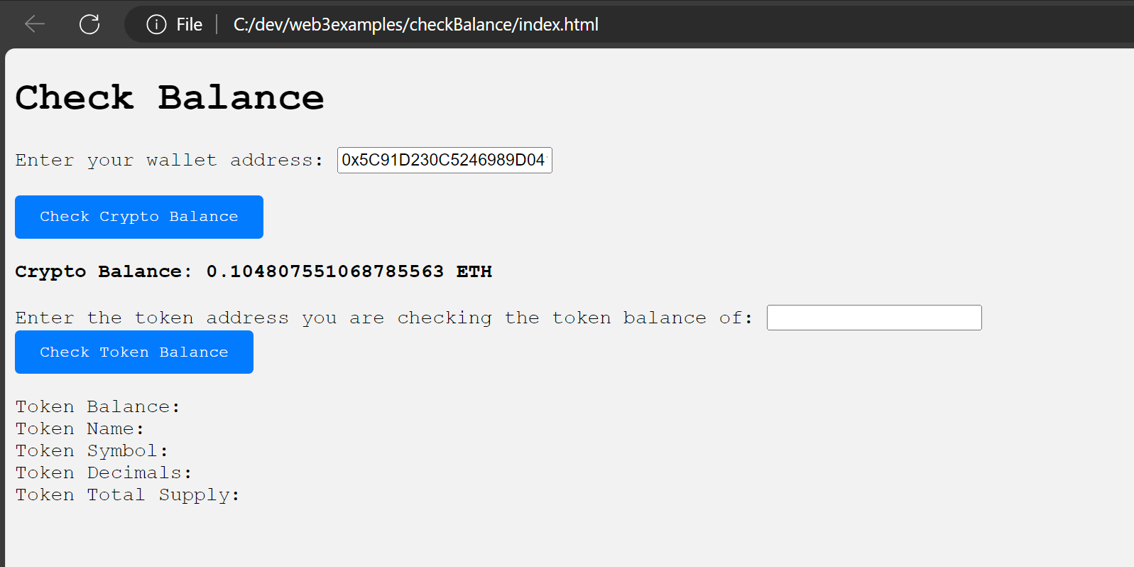

Decrypt Your Wallet
- Use the code example “decryptWallet” to open your encrypted wallet file with Web3.
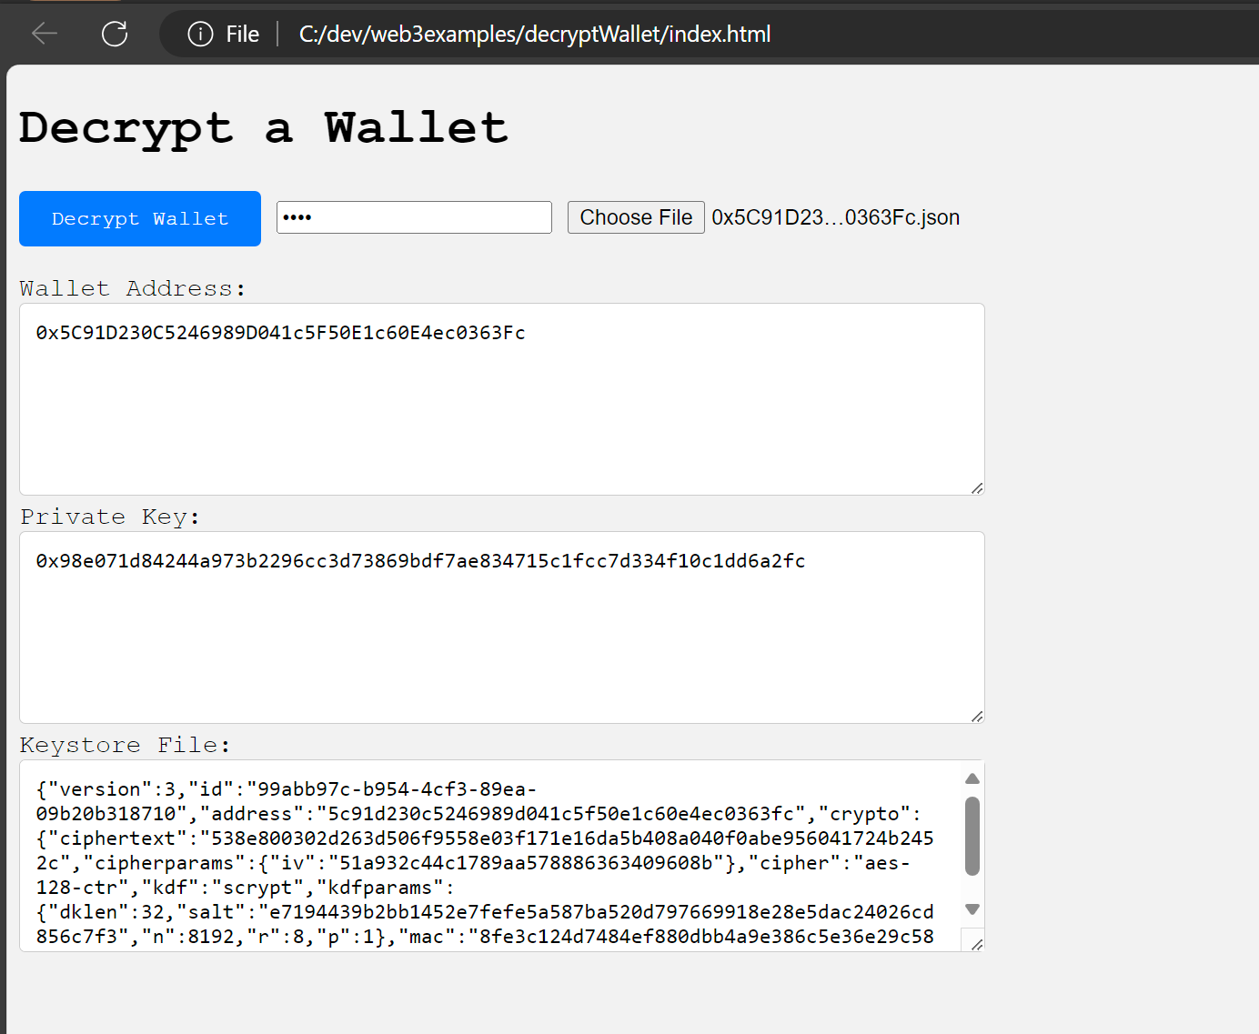

Project Work
- Use what you have learned to begin implementing some of the wallet management related features of your project.

